Lucas Cardona

Professor Walter

ENGRMAE 151A

Feb. 26, 2025

Individual Component Analysis;

Load Cell

**Description:**

The 7 Degree of Freedom (7 DoF) Robotic Arm must be able to receive feedback data in regards to how much grip force it is applying at the end effector. Therefore, the design must include some sensor with the ability to detect the applied force on the object. This verifies a need for selecting an appropriate type of sensor and for this design a bar load cell was chosen. The bar style load cell is advantageous to the design as it can function as part of the “fingers” saving on the amount of needed plastic for injection molding. This being considered, the main requirements for the load cell are that it must be able to withstand the forces needed for holding a 400g object, have an overall length exceeding 45mm, and have an accuracy of +/- 0.1g or better.

**Essential Qualities of Load Cells:**

* Force sensing:
  + Ensuring the robotic arm applies the correct force when grasping objects.
* Closed-loop control:
  + Enabling feedback mechanisms for improved accuracy and responsiveness.
* Safety compliance:
  + Preventing overloading or excessive force application that could damage components or objects.

**Functional Requirements:**

| **Label** | **Description** | **Justification** |
| --- | --- | --- |
| FR-3.1 | Withstand the force of holding a 400g object. | Being able to hold up and manipulate a 500g object is a requirement of our project. Therefore the load cell must be able to withstand the force necessary to do this. |
| FR-3.2 | Overall length at or exceeding 45mm | The original grippers of a previous ROBOTIS design are near 50mm, in order for the plastic savings to be advantageous the load cell must make up most of this distance. |
| FR-3.3 | Accuracy of +/- 0.1g or better | In order for the feedback system to function the machine learning algorithm must be given accurate data. This will improve the overall performance of the end effector as well as allow a wider variety of objects to be manipulated. |

**Selected Options:**

500G Load Cell (TAL221): 1kg Load Cell (YZC-133): 5kg Load Cell (YZC-133):

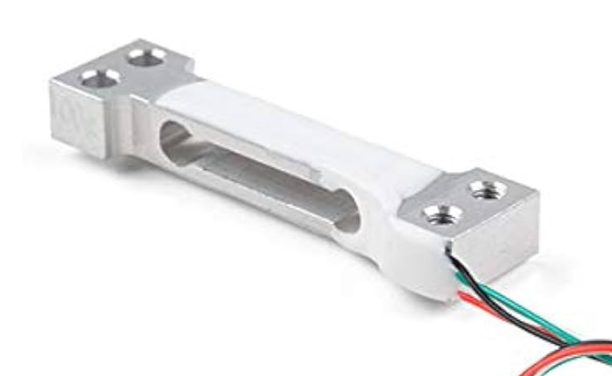 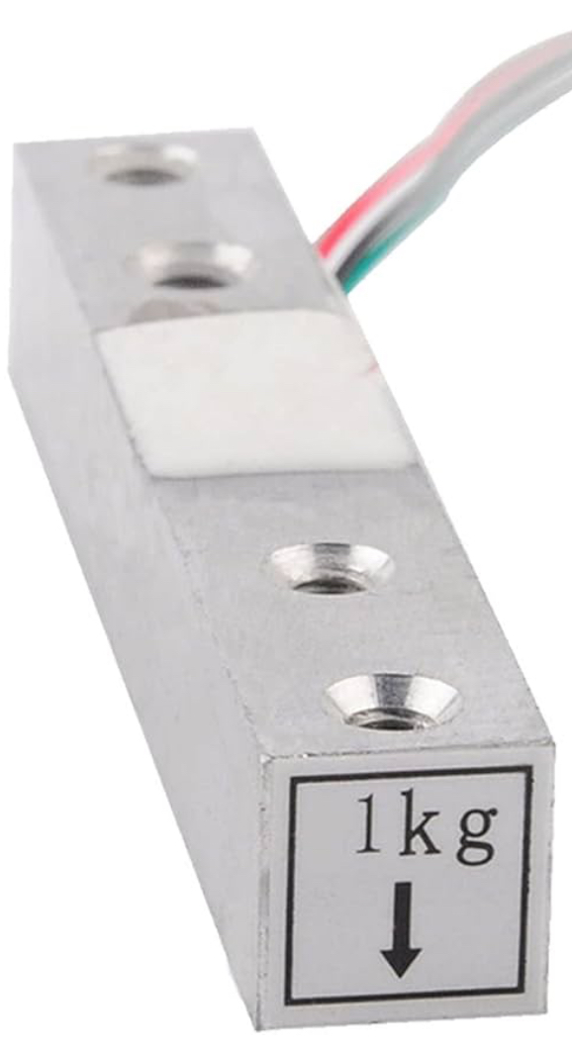 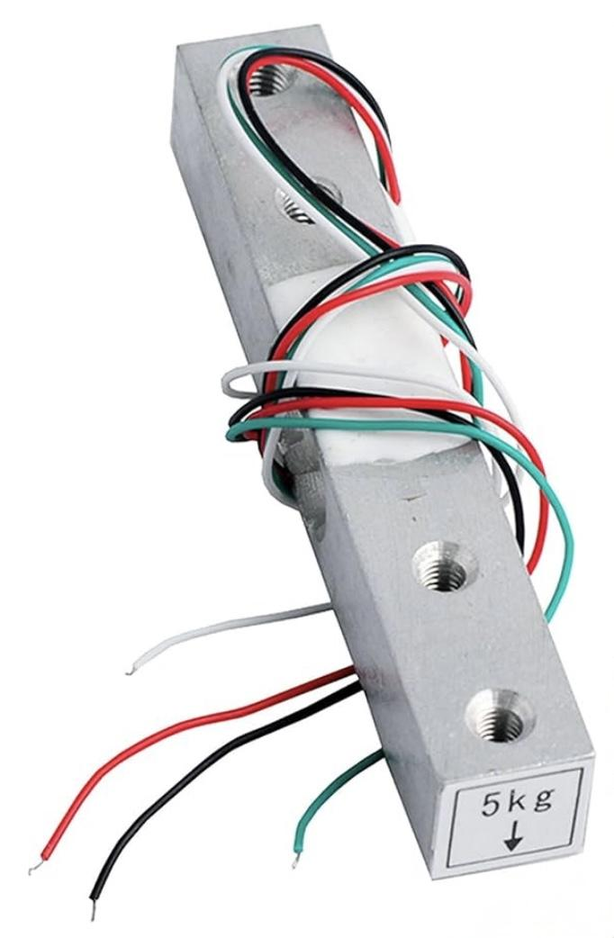

Overview: Overview: Overview:

- Length: 45mm - Length: 80mm - Length: 80mm

- Overload Capacity: 1000g - Overload Capacity: 1500g - Overload Capacity: 7500g

- Accuracy: 0.7 +/- 0.15 mV/V - Accuracy: 1.0 +/- 0.15 mV/V - Accuracy: 1.0 +/- 0.15 mV/V

All 3 options of the compared load cells use strain gauges to measure deformation in the bar. This specific method of measuring applied force is advantageous for our application because they offer high precision and reliability when compared to other options. These are essential qualities for ensuring our end effector can precisely know how much force it is applying and understand the object it is holding. Additionally, strain gauge load cells are very cost-effective allowing our project to remain under budget and be cheap to service. Different bar style load cells were also selected because much of the intended length for the end effectors claws will come from the body of the cell. A few drawbacks of these specific types of load cells are that they require amplification and can be susceptible to temperature variation. In our application temperature variation will not be much of a concern as the working environment will be a desktop. The need for an additional amplifier will affect our overall budget, however they are also cost-effective (~$10/piece).

**Weighted Component Matrix:**

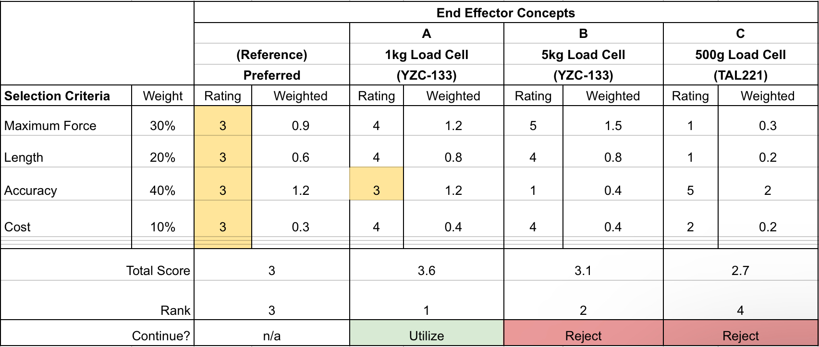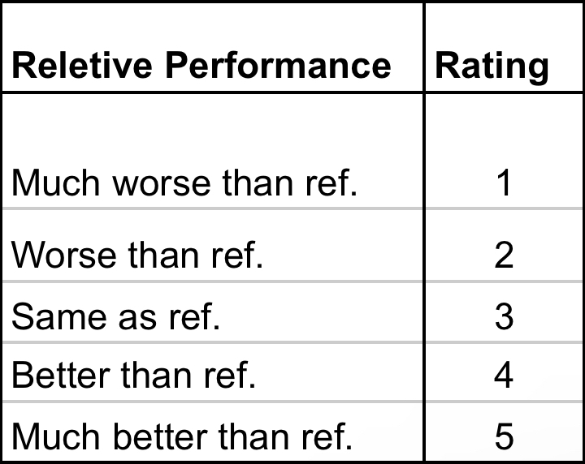

**Summary Table:**

| Component | Price | Pros | Cons |
| --- | --- | --- | --- |
| 1kg Bar Load Cell  (YZC-133) | $4.99 per unit | * 80mm in length * Appropriate range for application | * Lower safe overload percentage |
| 5kg Bar Load Cell  (YZC-133) | $4.99 per unit | * 80mm in length * Wide range of measurement | * Low accuracy * Lower safe overload percentage |
| 500g Load Cell  (TAL221) | $11.25 per unit | * Higher safe overload percentage   + 150% Rated Load | * Sub-par length * Smaller range of outputted voltage |

**Analysis:**

To ensure that the load cell is capable of handling the forces necessary for holding up a 400g object the following calculations were performed. A free body diagram shows 125% the mass target being held up by the friction forces of the object from the rubber pads of the end effector. To calculate the applied force necessary, first the force of friction was calculated based upon the static loading in the vertical direction. Next to ensure that the frictional force was sufficient to hold the object, an assumption of rubber on plastic for the coefficient of friction was used to find the necessary force to apply at the end effector. This force value was then converted to kilograms to ensure that the cell has enough range to handle the application.

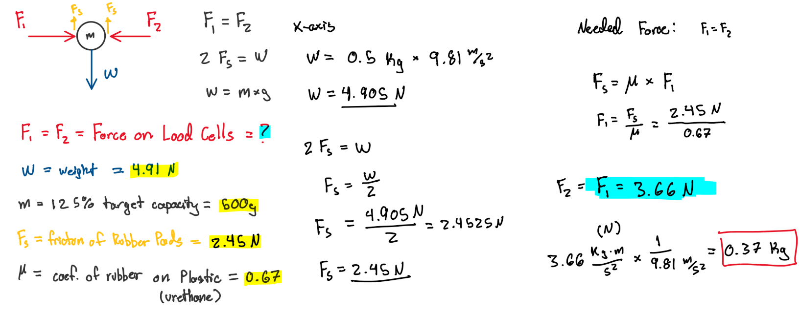Factor of Safety:

To allow the arm to grip objects with enough force to manipulate them without slipping a factor of safety of over 2 was chosen to ensure this. Given the necessary **0.37 kg** the cells needs to withstand, a 1kg load cell is able to offer a factor of safety over 2 with enough fidelity for our system.

$Factor of Safety=\frac{Max Load}{Designed Load}$

$FOS=\frac{0.5kg}{0.37kg}=1.35$ $FOS=\frac{1.0kg}{0.37kg}=2.70$ $FOS=\frac{5.0kg}{0.37kg}=13.5$

**Justification for the Chosen Load Cell:**

Based on the analysis above, the 1kg strain gauge-based load cell was selected for use in the end effector of the robotic arm. The main factor for this decision are its;

* Proven reliability in industrial applications.
* Cost-effectiveness compared to other options (piezoelectric; capacitive).
* High accuracy.
* Easy integration.
* Ability to handle a wide range of forces within our specifications.

**Chosen Component Specifications:**

1kg Load Cell (YZC-133)

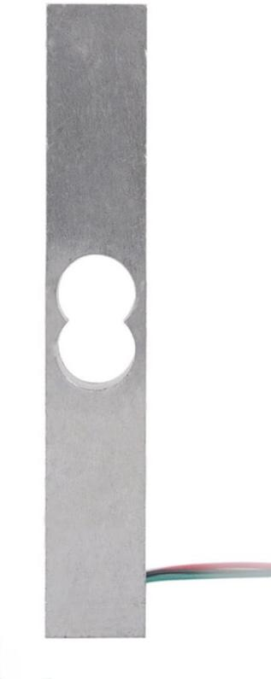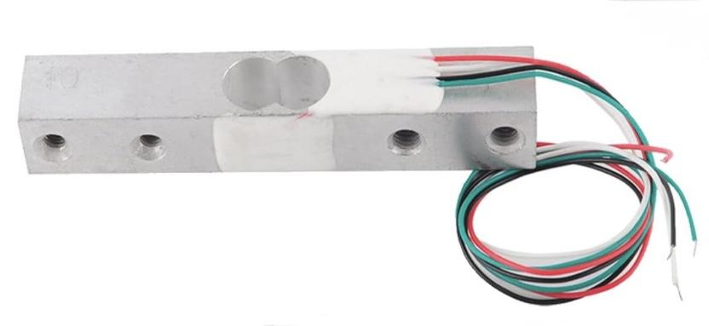

| **Specification** | **Value** |
| --- | --- |
| Rated Output: | 1.0 ± 0.15 mV/V |
| Nonlinearity: | 0.0005 |
| Repeatability: | 0.0003 |
| Hysteresis: | 0.0003 |
| Creep(5Min): | 0.001 |
| Temperature Effect On Sensitivity: | 0.003% RO/°C |
| Temperature Effect On Zero: | 0.02% RO/°C |
| Zero Balance: | ± 0.1% RO |
| Input Resistance: | 1066 ± 20Ω |
| Output Resistance: | 1000 ± 20Ω |
| Insulation Resistance: | 2000MΩ (50V) |
| Recommended Excitation Voltage: | 5V |
| Compensated Temperature Voltage: | -10 ~+ 50 °C |
| Operating Temperature Range: | -20 ~+65 °C |
| Safe Overload: | 120% RO |
| Ultimate Overload: | 150% RO |
| Load Cell Material: | Aluminium |
| Connecting Cable: | 0.8 X 180 mm |

References

Sparkfun. (n.d.). *Tal221 miniature load cell*. 500g Load Cell Data Sheet. https://cdn.sparkfun.com/assets/9/9/a/f/3/TAL221.pdf

*Geekstory Digital Load Cell Weight Sensor 1kg High Precision Miniature Load Cells YZC-133 for Arduino DIY Electronic Portable Kitchen Scale Sensors(Pack of 2): Amazon.com: Industrial & Scientific*. (2025). Amazon.com. <https://www.amazon.com/Geekstory-Digital-Load-Weight-Sensor/dp/B0CJYC7L92?th=1>

Hastawan, A. F., Haryono, S., Utomo, A. B., Hangga, A., Setiyawan, A., Septiana, R., Hafidz, C. M., & Triantino, S. B. (2021). Comparison of testing load cell sensor data sampling method based on the variation of time delay. *IOP Conference Series: Earth and Environmental Science*, *700*(1), 012018. <https://doi.org/10.1088/1755-1315/700/1/012018>

*The Ultimate Showdown: Load Cell Comparison Demystified*. (2025). Dubai Sensor. <https://www.dubai-sensor.com/blog/the-ultimate-showdown-load-cell-comparison-demystified/>